**ACCEPTANCE TEST PROCEDURE**

**FOR**

**DISPLAY 17”**

**(BEL Part No: - 4805 126 607 87)**

|  |  |  |  |
| --- | --- | --- | --- |
| **P.O. No.** | **BEPO / E3 / 4000396523** | **DATED:** | **22-08-2023** |
| **PREPARED BY.** | **PURUSHOTHAM REDDY** | **APPROVED BY** | **Mr**. **RAJMOHAN. K** |
| **SIGNATURE.** |  | **SIGNATURE.** |  |
| **BEL (Rep) NAME** | **Mr**. | **APPROVED BY.** | **Mr**. |
| **SIGNATURE.** |  | **SIGNATURE.** |  |

**SUPPLIED TO:**



**M/S BHARAT ELECTRONICS LIMITED,**

**MANUFACTURED BY:**



**M/S DATASOL (B) PVT. LTD,**

**BANGALORE – 560 045.**

TABLE OF CONTENTS

|  |  |  |
| --- | --- | --- |
|  | **DESCRIPTION** | **PAGE NO** |
| 1.0 | Scope | 3 |
| 1.1 | Identification | 3 |
| 1.3 | Brief Description | 4 |
| 2.0 | Specifications | 4 |
| 3.0 | Test Equipment Required | 4 |
| 4.0 | Physical Inspection | 5 |
| 5.0 | Functional Test Procedure | 5 |
| 6.0 | Hardware Details | 6 |
| 6.1 | Display Specification | 6 |
| 6.2 | Power Supply Specification | 7 |
| 6.3 | AC Power Entry Modules | 8 |
| 7.0 | Block Diagram | 9 |
| 8.0 | Test Setup | 9 |
| 9.0 | Wiring Details | 10 |
| 9.1 | Power Supply O/P To AD Board | 10 |
|  | Physical Test Report-TDR-1 | 10 |
|  | Functional Test Report - TDR-2 | 11 |

**Images**

|  |  |  |
| --- | --- | --- |
|  | **DESCRIPTION** | **PAGE NO** |
| Image1 | DBPL-24HD-01 | 3 |
| Image2 | Display | 6 |
| Image3 | Power Supply | 7 |
| Image4 | Block Diagram | 8 |
| Image5 | Test Setup | 9 |
| Image6 | Wiring Details | 9 |

**1.0 SCOPE**

This document defines the procedure that is to be followed during the process of acceptance of the

DISPLAY 17” for fulfilling the needs of BEL BLR, as per the Purchase Order.

* 1. **IDENTIFICATION**

The DISPLAY 17” supplied by M/S Datasol to M/S Bharat Electronics Limited will be here after identified as given below.

Description : Display 17”

MFG P/N : DBPL-17HD-01

BEL Part Number : 4805 126 607 87

MFG Year :

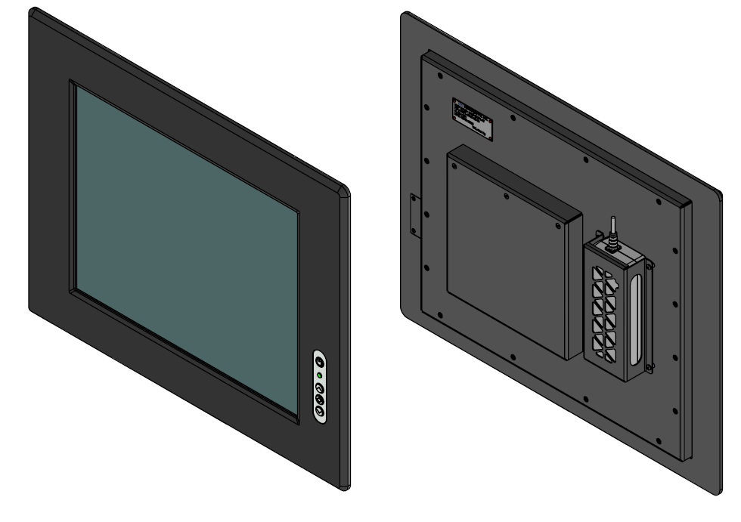

**Image1 - DBPL-24HD-01**

**1.3 Brief Description**

This specification applies to the 17-inch-wide Colour a-Si TFT-LCD Module M170ETN01.1. The

display supports the SXGA+ (1280(H) x 1024(V)) screen format and 16.7M colour (RGB 6-bits +

Hi-FRC data). The input interface is Dual channel LVDS and this module doesn’t contain an

driver board for backlight.

**2.0: Specifications**

* **Front panel Control:** OSD control keypad
* **Connection:** AC Input, VGA,Connector
* **Display:** 24” with resolution 1280 X 1024
* **Dimensions (W x H x D):** Details in TDR-1
* **Weight:** < 8±1 Kgs

**3.0: Test Equipment Required:**

Test PC with VGA port - 1 No

VGA cable -1 No

Power chords -2 No

Keyboard -1 No

Mouse -1 No

**4.0: Physical Inspection**

1.Check the Display for any damages

2. Check if the power circular connector is properly mating at the Display end and also clearly inserted at the power socket.

3. Check all the connectors, power & signal for any loose pins/wires.

4. Check the measurements as specified in TDR-1 and note down the result in TDR-1.

**5.0: Functional Test Procedure:**

1. Connect the Display to the CPU of a PC. After switching ON the power to Display check the system booting and display seen on the screen of Display.

2. Check the Resolution 1280x1024

3. Note down the results in TDR-2.

4. After checking, shutdown the system and switch off the Display Unit.

**6. Hardware details:**

**6.1. Display Specification**

**P/N: M170ETN01-V1**

This specification applies to the 17-inch-wide Colour a-Si TFT-LCD Module M170ETN01.1. The

display supports the SXGA+ (1280(H) x 1024(V)) screen format and 16.7M colour (RGB 6-bits +

Hi-FRC data). The input interface is Dual channel LVDS and this module doesn’t contain an

driver board for backlight.

. 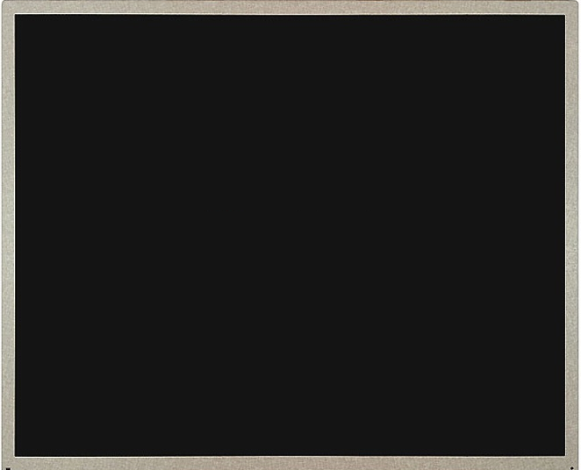

**Image2 - Display**

|  |  |
| --- | --- |
| **Parameter** | **Specification** |
| Resolution | 1280×1024 |
| Contrast Ratio | 1000:1 |
| Display Colours | 16.7M |
| Brightness | 250 |
| Viewing angle U/D/L/R | 85/85/80/80 |
| Display Size | 17” |
| Frame Rate | 60Hz |
| Operating Temperature | 0 ~ 50 °C |

**6.2. Power supply Specification**

**P/N: GST90A12-P1M**

AC-DC Industrial desktop adaptor with PFC; Input 3 pin IEC320-C14 socket; Output 12VDC at 6.67A with P1M tuning fork plug OD 5.5mm; ID 2.5mm; Length 1000±50 mm

.



**Image3 -Power Supply**

|  |  |
| --- | --- |
| **Parameter** | **Specification** |
| Input Voltage | 90~264 VAC |
| Output Voltage-Channel | 12 VDC |
| Output Current-Channel | 6.67 A |
| Input Frequency | 47 ~ 63Hz |
| Power - Convection | 80 W |
| OPERATING TEMP. | -30 to +70C |

**7. Block Diagram**

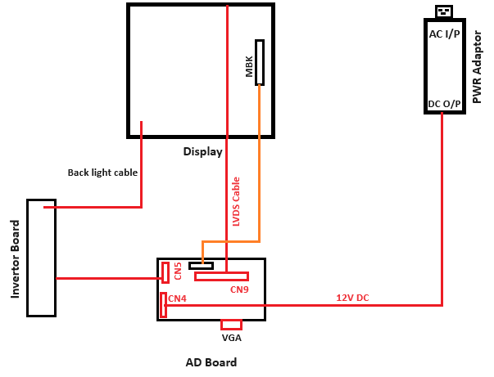

**Image4 -Block Diagram**

**8. Test Setup**

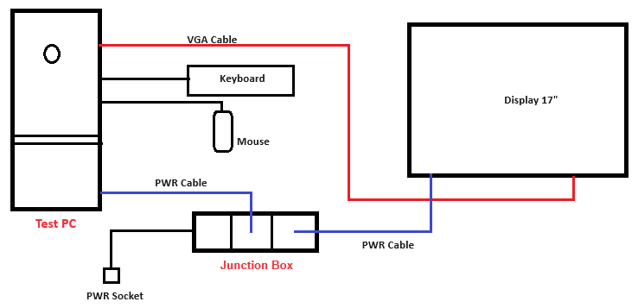

**Image5 – Test Setup**

**9. Wiring Details**

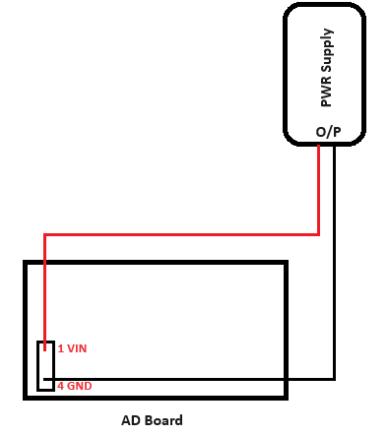

**Image6 -Wiring Details**

**9.1. Power Supply O/P to AD Board**

|  |  |  |  |  |  |  |
| --- | --- | --- | --- | --- | --- | --- |
| **PWR Supply O/P** | **Wire code** | **Signal Description** |  | **AD Board** | **Pin no** | **Signal Description** |
| **GST90A12-P1M** | Red | LINE | ------> | **CN18** | Pin 1 | VIN |
| Black | NEUTRAL | ------> | Pin 4 | GND |

**Physical Test Report - TDR-1 Date:**

**BEL Part No: 4805 126 607 87**

**Description: Display 17”**

**Unit Serial Number:**

**PHYSICAL CHECK:**

|  |  |  |  |
| --- | --- | --- | --- |
| **S.NO** | **TEST** | **REQUIREMENT** | **RESULT** |
| 1 | Display 17” damages check | No damages | OK /NOT OK |
| 2 | Mating of power cable | Proper fitment | OK /NOT OK |

**DIMENSIONAL CHECK:**

|  |  |  |  |  |
| --- | --- | --- | --- | --- |
| **S.NO** | **DESCRIPTION** | **SPECIFIED DIMENSIONS(MM)** | **MEASURED DIMENSIONS(MM)** | **RESULT** |
| 1 | Width | 482± 2.0 |  | OK /NOT OK |
| 2 | Height | 398± 2.0 |  | OK /NOT OK |
| 3 | Depth | 60± 2.0 |  | OK /NOT OK |
| 4 | Weight | 8 ±1Kgs |  | OK /NOT OK |

**RESULT: OK / NOT OK**

**Rremarks If Any:**

**Tested By: Verified By:**

**Functional Test Report - TDR-2 Date:**

**BEL Part No: 4805 126 607 87**

**Description: Display 17”**

**Unit Serial Number:**

|  |  |  |  |
| --- | --- | --- | --- |
| **S. No** | **Test** | **Requirement** | **Result** |
| 1 | After switching ON the power to Display & Test PC check if the system got booted and display is seen on the screen of the unit. Set the Resolution to 1280x1024 and check if the set resolution is supported and displayed on the screen. | Resolution up to 1280x1024 | OK / NOT OK |

**RESULT: OK / NOT OK**

**Rremarks If Any:**

**Tested By: Verified By:**